**ALL LAB CODES**

**LAB 1**

**1.1 Type and compile the program and remove errors and then run it.**

#Include <<iostream>> Using namespace Std int main () { Cout << welcome to the new batch\n; Cout < "it is our first class", Cout < "it is errorless",, Cout <we learn programming”; System(pause); return (0); }

**#Include <<iostream>> //the i of include was capital, extra < >**

**Using namespace Std //the u of using and s of std was capital, terminator was missing**

**int main()**

**{**

**//all cout's c was capital**

**Cout << welcome to the new batach\n; // inverted commmas were missing**

**Cout < "it is our first class", // < was missing and commas were in place of terminater**

**Cout < "it is errorless",, //two commas were present in place of a terminator**

**Cout < we learn programing"; //less than sign was missnig**

**return (0); // additional () brackets are present**

**}**

**SOURCE CODE AND OUTPUT**

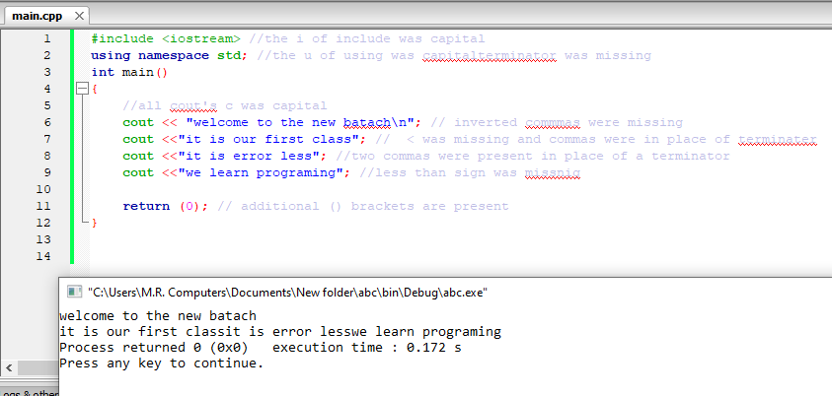

**1.2 writes a program to create a simple CV .Print all the requirements that are needed to be in making CV.**

**SOURCE CODE**

#include <iostream>

using namespace std;

int main()

{

cout<<"________________________________________________________________________________________"<<endl;

cout<<"|CV |"<<endl;

cout<<"|-- |"<<endl;

cout<<"|======FUTURE VISION====== |"<<endl;

cout<<"|To be the CEO of my very own software house |"<<endl;

cout<<"|======BIO DATA====== |"<<endl;

cout<<"|Nabeel Rizwan Quadri son of Syed Rizwan Quadri |"<<endl;

cout<<"|Date of birth 20-06-2000 |"<<endl;

cout<<"|mob. no. 03362319053 |"<<endl;

cout<<"|Email ID mr.nabeelrizwan@gmail.com |"<<endl;

cout<<"|======QUALIFICATIONS====== |"<<endl;

cout<<"|bachelor's in computer science from Hamdard university |"<<endl;

cout<<"|Inter from bufferone collage in pre-engineering |"<<endl;

cout<<"|Matric form Pakistani international school in biology |"<<endl;

cout<<"|======SKILLS====== |"<<endl;

cout<<"|Expert programmer in over 10 different languages |"<<endl;

cout<<"|======Communication Skills====== |"<<endl;

cout<<"|Expert in English speaking and writing |"<<endl;

cout<<"|======Interests====== |"<<endl;

cout<<"|Creative writing, Debating and reading books |"<<endl;

cout<<"|______________________________________________________________________________________|"<<endl;

return 0;

}

**OUTPUT**

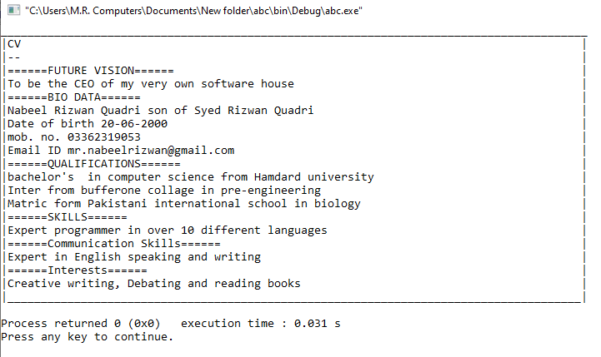

**LAB 2**

**2.1 Write a program to create a form of Nadra in which all fields are required by using escape sequences.**

**SOURCE CODE**

**#include <iostream>**

**using namespace std;**

**int main()**

**{**

**cout<<"\t\tNADRA REGISTRATION FORM\n\n";**

**cout<<"\'FIll the form as per instructed\'\n\n\a";**

**cout<<"Enter your full name in block letters \n____________________________\n\n";**

**cout<<"Enter Father's full name in block letters \n____________________________\n\n";**

**cout<<"Enter date of birth (DD\\MM\\YY)\n____________________________\n\n";**

**cout<<"Select your gender Male\\Female \n\n";**

**cout<<"Enter permanent home address\n____________________________\n\n";**

**cout<<"Enter current home address\n____________________________\n\n";**

**cout<<"Do you have a \"mark of identification\"\?\n____________________________\n\n";**

**return 0;**

**}**

**OUTPUT**

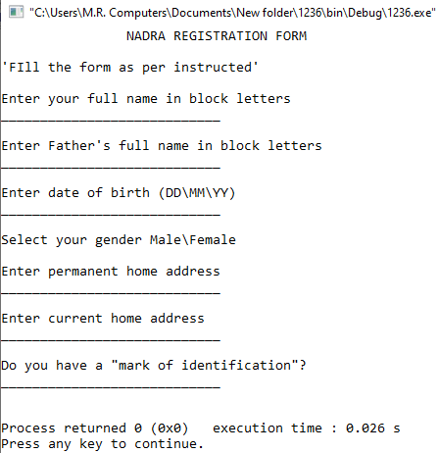

**2.2. Write a C++ program to illustrate “\r “escape sequence.**

**SOURCE CODE**

**#include <iostream>**

**using namespace std;**

**int main()**

**{**

**cout<<"nabeel rizwan quadri"<<endl;**

**cout<<"nabeel \rrizwan quadri"<<endl;**

**cout<<"nabeel rizwan \rquadri"<<endl;**

**cout<<"nabeel \r rizwan \rquadri"<<endl;**

**return 0;**

**}**

**OUTPUT**

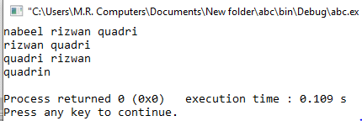

**2.3 Write a C++ program to illustrate \' escape sequence, \" escape sequence and \? Escape sequence.**

**SOURCE CODE**

**#include <iostream>**

**using namespace std;**

**int main()**

**{**

**cout<<"The news reporter, \"will they win the match\?\""<<endl;**

**cout<<"Misbah-ul-haq,\"The overall team is in good shape except for \'that one player\' but even he can perform well.\""<<endl;**

**return 0;**

**}**

**OUTPUT**

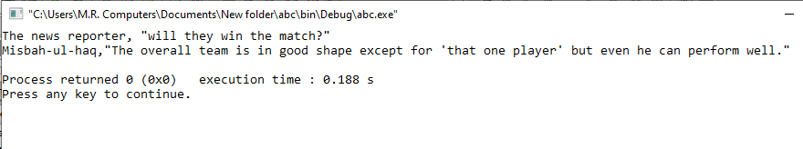

**LAB 3**

**3.1 Take input of two numbers then calculate their sum, difference, product and quotient then output the result**

**SOURCE CODE**

**#include <iostream>**

**using namespace std;**

**int main()**

**{**

**float a,b,c;**

**cout<<"Enter two numbers"<<endl;**

**cin>>a>>b;**

**c=a+b;**

**cout<<a<<"+"<<b<<"="<<c<<endl;**

**c=a-b;**

**cout<<a<<"-"<<b<<"="<<c<<endl;**

**c=a*b;**

**cout<<a<<"*"<<b<<"="<<c<<endl;**

**c=a/b;**

**cout<<a<<"/"<<b<<"="<<c<<endl;**

**return 0;**

**}**

**OUTPUT**

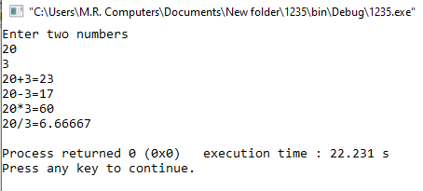

**3.2 Take input for the radius of a circle then calculate its area, circumference and diameter, then output the three results.**

**(Area= π r2 circumference=2πr diameter=2r)**

**SOURCE CODE**

**#include <iostream>**

**using namespace std;**

**int main()**

**{**

**float R,B;**

**cout<<"Enter radius of circle"<<endl;**

**cin>>R;**

**B=(R*R)*3.15;**

**cout<<"Area of circle is "<<B<<endl;**

**B=2*3.14*R;**

**cout<<"Circumference of circle is "<<B<<endl;**

**B=R/2;**

**cout<<"Diameter of circle is "<<B<<endl;**

**return 0;**

**}**

**OUTPUT**

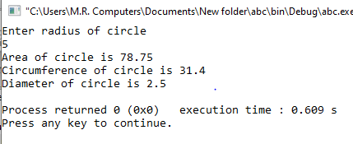

**3.3 Write a program that swaps values of two variables using a third variable.**

**SOURCE CODE**

**#include <iostream>**

**using namespace std;**

**int main()**

**{**

**float a,b,c;**

**cout<<"Enter first number"<<endl;**

**cin>>a;**

**cout<<"Enter second number"<<endl;**

**cin>>b;**

**cout<<"Before swap first number is "<<a<<endl;**

**cout<<"Before swap second number is "<<b<<"\n\n"<<endl;**

**c=a;**

**a=b;**

**b=c;**

**cout<<"After swap first number is "<<a<<endl;**

**cout<<"After swap second number is "<<b<<endl;**

**return 0;**

**}**

**OUTPUT**

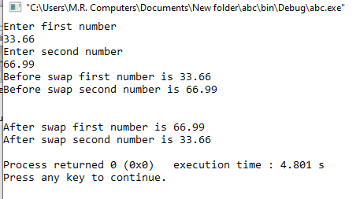

**3.4 A program that inputs an 8 digit binary number then converts it in Decimal. (Use of % operator, POW () function)**

**SOURCE CODE**

**#include <iostream>**

**#include <cmath>**

**using namespace std;**

**int main()**

**{**

**int A,B,C,D,E,F,G,H,ANS;**

**cout << "Conversion of Binary to decimal\n" << endl;**

**cout << "Convert 11010101 into decimal number system\n" <<endl;**

**A=1* pow (2, 0);**

**B=0* pow (2, 1);**

**C=1* pow (2, 2);**

**D=0* pow (2, 3);**

**E=1* pow (2, 4);**

**F=0* pow (2, 5);**

**G=1* pow (2, 6);**

**H=1* pow (2, 7);**

**ANS=A+B+C+D+E+F+G+H;**

**cout <<"11010101 in Decimal number system is \a"<<ANS<<endl;**

**return 0;**

**}**

**OUTPUT**

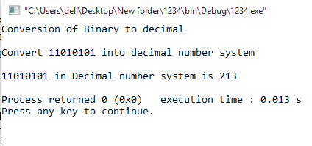

**3.5 write a program to convert dollar into rupees (1$= Rs.139)**

**SOURCE CODE**

**#include <iostream>**

**using namespace std;**

**int main()**

**{**

**float a,b;**

**cout<<"Enter Amount in dollars"<<endl;**

**cin>>a;**

**b=a*165.5;**

**cout<<"\n2Amount in Pakistani rupees is "<<b<<endl;**

**return 0;**

**}**

**OUTPUT**

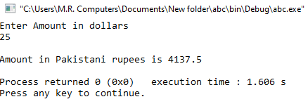

**LAB 4**

**4.1 Write a program determine whether the input number is even or odd**

**SOURCE CODE**

**#include <iostream>**

**using namespace std;**

**int main()**

**{**

**int a;**

**cout<<"Enter a number \n";**

**cin>>a;**

**if(a%2==0)**

**cout<<a<<" is an even number"<<endl;**

**else**

**cout<<a<<" is an odd number"<<endl;**

**return 0;**

**}**

**OUTPUT**

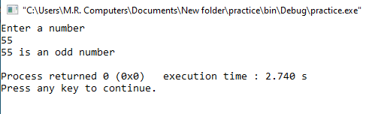

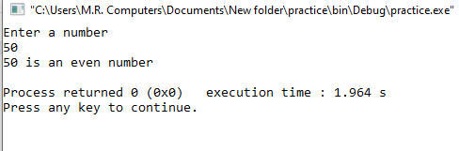

**4.2 Write a program to perform above task using switch case.**

**SOURCE CODE**

**#include <iostream>**

**using namespace std;**

**int main ()**

**{**

**int i, j, operation, operations;**

**cout<<"Enter a number \n";**

**cin>>i;**

**j=i%2;**

**cout<<j<<endl;**

**operation=j;**

**switch(operation)**

**{**

**case 0:**

**cout<<i<<" is an even number";**

**break;**

**default:**

**cout<<i<< " is an odd number";**

**}**

**return 0;**

**}**

**OUTPUT**

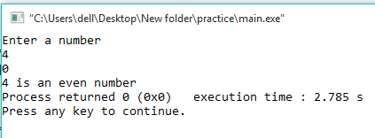

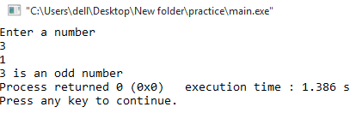

**4.3 write a program to generate a mark sheet which shows obtained marks, average and grade by using if else condition.**

**SOURCE CODE**

**#include <iostream>**

**using namespace std;**

**int main ()**

**{**

**int a,b,c,d,e,percentage,sum;**

**cout<<"Enter marks of 1st subject"<<endl;**

**cin>>a;**

**cout<<"Enter marks of 2nd subject"<<endl;**

**cin>>b;**

**cout<<"Enter marks of 3rd subject"<<endl;**

**cin>>c;**

**cout<<"Enter marks of 4th subject"<<endl;**

**cin>>d;**

**cout<<"Enter marks of 5th subject"<<endl;**

**cin>>e;**

**sum=a+b+c+d+e;**

**percentage=sum/5;**

**cout<<"\nTotal marks obtained by the student is "<<sum<<" out of 500\n"<<endl;**

**cout<<"Percentage of the student is "<<percentage<<"%\n"<<endl;**

**if (percentage>=90&&percentage<=100)**

**cout<<"Student has been awarded A grade"<<endl;**

**else if (percentage>=80&&percentage<=89)**

**cout<<"Student has been awarded B grade"<<endl;**

**else if (percentage>=70&&percentage<=79)**

**cout<<"Student has been awarded C grade"<<endl;**

**else if (percentage>=60&&percentage<=69)**

**cout<<"Student has been awarded D grade"<<endl;**

**else if (percentage>=50&&percentage<=59)**

**cout<<"Student has been awarded E grade"<<endl;**

**else if (percentage<50)**

**cout<<"Student has been awarded F grade"<<endl;**

**return 0;**

**}**

**OUTPUT**

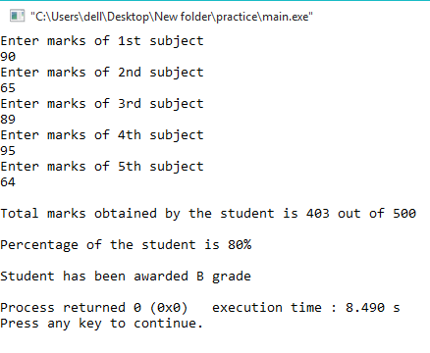

**4.4 Write a program to detect whether the input character is an UPPER CASE letter or LOWER CASE or if it is a SPECIAL CHARACTER**

**SOURCE CODE**

**#include <iostream>**

**using namespace std;**

**int main()**

**{**

**char a, lowercaseletter, UPPERCASELETTER, specialcharacters;**

**cout << "Enter a Character" << endl;**

**cin>>a;**

**lowercaseletter = (a=='a' || a=='b' || a=='c' || a=='d' || a=='e' || a=='f' || a=='g' || a=='h' || a=='i' || a=='j' || a=='k' || a=='l' || a=='m' || a=='n' || a=='o' || a=='p' || a=='q' || a=='r' || a=='s' || a=='t' || a=='u' || a=='v' || a=='w' || a=='x' || a=='y' || a=='z');**

**UPPERCASELETTER = (a=='A' || a=='B' || a=='C' || a=='D' || a=='E' || a=='F' || a=='G' || a=='H' || a=='I' || a=='J' || a=='K' || a=='L' || a=='M' || a=='N' || a=='O' || a=='P' || a=='Q' || a=='R' || a=='S' || a=='T' || a=='U' || a=='V' || a=='W' || a=='X' || a=='Y' || a=='Z');**

**specialcharacters = (a=='!' || a=='@' || a=='#' || a=='$' || a=='%' || a=='^' || a=='&' || a=='*' || a=='(' || a==')' || a=='_' || a=='-' || a=='=' || a=='+' || a=='|' || a=='[' || a==']' || a=='{' || a=='}' || a==';' || a=='"' || a==':' || a=='/' || a=='?' || a=='.' || a==','|| a=='<' || a=='>' || a=='/' || a=='*' || a=='-');**

**//NOT INCLUDED SPECIAL CHARACTERS ' and \ only**

**if (lowercaseletter)**

**cout<<a<<" is a lowercase letter"<<endl;**

**else if(UPPERCASELETTER)**

**cout<<a<<" is a uppercase letter"<<endl;**

**else if(specialcharacters)**

**cout<<a<<" is a special character"<<endl;**

**else**

**cout<<a<<" is an invalid character"<<endl;**

**return 0;**

**}**

**OUTPUT**

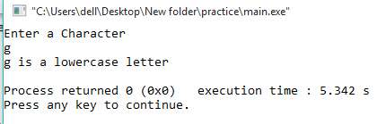

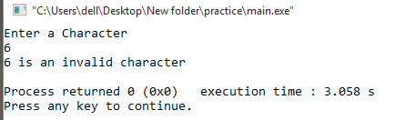

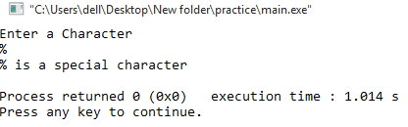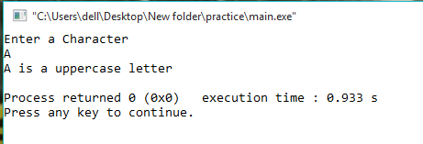

**LAB 5**

**5.1 Write a program that prints “yes” if the given integer is divisible by 2 or 3 and “no” otherwise.**

**SOURCE CODE**

#include <iostream>

using namespace std;

int main ()

{

int a;

cout<<"Enter the number to be checked"<<endl;

cin>>a;

if (a%2!=1||a%3!=1)

cout<<"YES"<<endl;

else

cout<<"NO"<<endl;

return 0;

}

**OUTPUT**

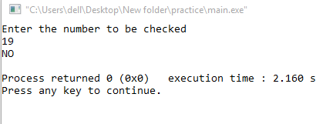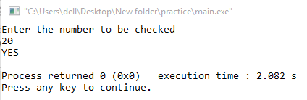

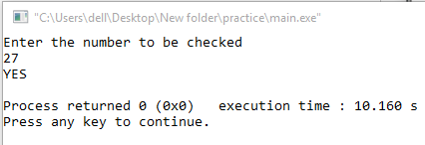

**5.2 Write a Program that prints “Take a day off!" if it takes the number of customer greater than 50 and their total sum would be greater or equivalent to 5000.**

**SOURCE CODE**

#include <iostream>

using namespace std;

int main ()

{

int a,b=0;

cout<<"Enter the number of customers"<<endl;

cin>>a;

for(int i=1; i<=a;i++)

{

b+=i;

}

cout<<"total no. of customers are "<<a<<endl;

cout<<"Sum of all customers is "<<b<<endl;

if (a>50&&b>5000)

cout<<"take a day off!"<<endl;

return 0;

}

**OUTPUT**

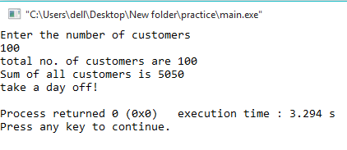

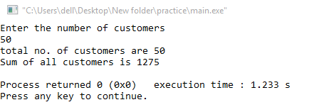

**LAB 6**

**6.1 Program that prints first 20 integers in reverse order**

**SOURCE CODE**

#include <iostream>

using namespace std;

int main ()

{

for (int x=20; x>=0; x--)

{

cout<<x<<endl;

}

return 0;

}

**OUTPUT**

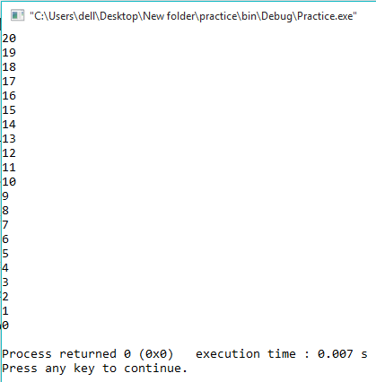

**6.2 Write a program to generate a Fibonacci Series of given numbers of n terms.**

**SOURCE CODE**

#include <iostream>

using namespace std;

int main() {

int n1=0,n2=1,n3,i,number;

cout<<"Enter the number of elements: ";

cin>>number;

cout<<n1<<" "<<n2<<" ";

for(i=2;i<number;++i)

{

n3=n1+n2;

cout<<n3<<" ";

n1=n2;

n2=n3;

}

return 0;

}

**OUTPUT**

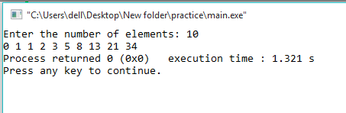

**6.3 Write a program in C++ to check whether a number is prime or not**

**SOURCE CODE**

#include <iostream>

using namespace std;

int main ()

{

int a,b=0,c=0,d=0;

cin>>a;

c=a;

do

{

a--;

b=a;

for(int i=2; i<=a; i++)

{

d=i*b;

if(d==c)

{

cout<<"Number is not prime"<<endl;

return 0;

}

}

}

while(a>=0);

if(d!=c)

{

cout<<"Number is prime"<<endl;

}

return 0;

}

**OUTPUT**

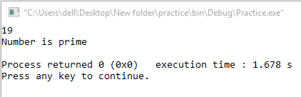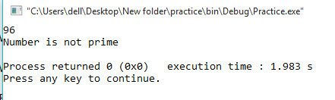

**6.4 Write a Program to generate an Armstrong number**

**SOURCE CODE**

#include <iostream>

using namespace std;

int main() {

int num, sum = 0, digit;

cout<<"Enter a positive integer: ";

cin>>num;

for(int I=num; I!=0;){

digit = I % 10;

sum = sum +(digit * digit * digit);

I = I/10;

}

if(sum == num)

cout<<num<<" is an Armstrong number.";

else

cout<<num<<" is not an Armstrong number.";

return 0;

}

**OUTPUT**

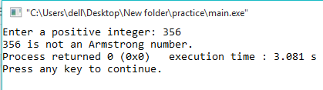

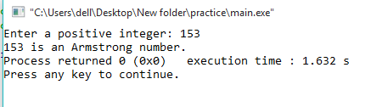

**6.4 Write a Program to generate an Armstrong number**

**SOURCE CODE**

#include <cmath>

#include <iostream>

using namespace std;

int main(){

int sum, num;

cout<<"Armstrong numbers between 1 and 1000: ";

for(int i = 0; i < 10; i++) {

for(int j = 0; j < 10; j++) {

for(int k = 0; k < 10; k++) {

num = i * 100 + j * 10 + k;

sum = pow(i, 3) + pow(j, 3) + pow(k, 3);

if(num == sum)

cout<<num<<" ";

}

}

}

return 0;

}

**OUTPUT**

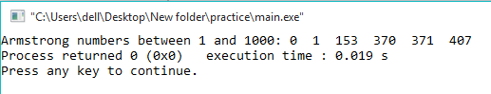

**LAB 7**

**7.1 Write a program to list the names of weekdays by using switch case. (USE OF BREAK KEYWORD IS MANDATORY).**

**SOURCE CODE**

#include <iostream>

using namespace std;

int main()

{

int weeknumber;

cout<<"Enter week number(1-7): ";

cin>>weeknumber;

switch(weeknumber)

{

case 1: cout<<"Monday";

case 2: cout<<"Tuesday";

case 3: cout<<"Wednesday";

case 4: cout<<"Thursday";

case 5: cout<<"Friday";

break;

case 6: cout<<"Saturday";

case 7: cout<<"Sunday";

default: cout<<"Invalid input! Please enter week no. between 1-7.";

}

return 0;

}

**OUTPUT**

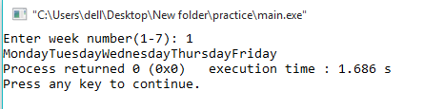

**7. 2 write a Program to Make a Simple Calculator to Add, Subtract, Multiply or Divide Using switch...case. (USE OF BREAK KEYWORD IS MANDATORY).**

**SOURCE CODE**

# include <iostream>

using namespace std;

int main()

{

char op;

float num1, num2;

cout << "Enter operator either + , - , * , /: ";

cin >> op;

cout << "Enter two operands: ";

cin >> num1 >> num2;

switch(op)

{

case '+':

cout << num1+num2 <<endl;

case '-':

cout << num1-num2<<endl;

case '*':

cout << num1*num2<<endl;

case '/':

cout << num1/num2<<endl;

break;

default:

cout << "Error! operator is not correct";

break;

}

return 0;

}

**OUTPUT**

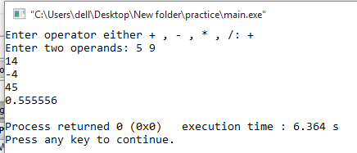

**7.3 Write a program in C++ to make such a pattern like triangle with number increased by 1**

**SOURCE CODE**

#include<iostream>

using namespace std;

int main()

{

int r, sp, p, no, n,j;

cout << "enter number of rows: ";

cin >> no;

n = no;

j=0;

for (r = 1; r <= no; r++) //for rows

{

for (sp = 1; sp <= n; sp++) //for space

{

cout << (" ");

}

n--;

for (p = 1; p <= r; p++)//for display values

{

j++;

cout << " " << j;

}

cout << "\n";

}

return 0;

}

**OUTPUT**

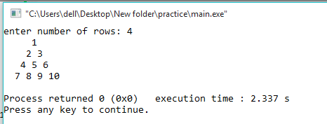

**7.4 Write a program in C++ to display the pattern like triangle using an asterisk.**

**SOURCE CODE**

#include<iostream>

using namespace std;

int main()

{

int i,j,k,n;

cout<<"Enter number of rows: ";

cin>>n;

for(i=1; i<=n; i++)

{

for(j=1; j<=n-i; j++)

{

cout<<" ";

}

for(k=1; k<=(2*i)-1; k++)

{

if(i<n)

if(k==1 || k==(2*i)-1)

cout<<"*";

else

cout<<" ";

else if(i==n)

cout<<"*";

}

cout<<endl;

}

return 0;

}

**OUTPUT**

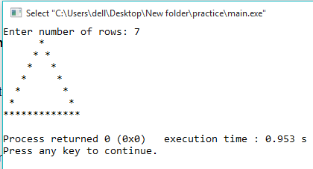

**PF lab 8**

**8.1 Write a C++ program to add two integers. Make a function add() to add integers and display sum in main() function.**

**SOURCE CODE**

**#include<iostream>**

**using namespace std;**

**int main()**

**{**

**int a(int , int );**

**int b,c,result;**

**cout<<"Enter first number:"<<endl;**

**cin>>b;**

**cout<<"Enter second number:"<<endl;**

**cin>>c;**

**result=a(b,c);**

**cout<< b << "+" << c << "=" << result<<endl;**

**return 0;**

**}**

**int a(int a, int b)**

**{**

**int R;**

**R=a+b;**

**return(R);**

**}**

**OUTPUT**

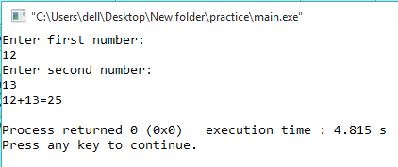

**8.2 Using functions write a program which takes the radius of a circle as input from the user, computes the area of the circle in function and display the area of the circle in the main body. Use data type: float.**

**SOURCE CODE**

**#include<iostream>**

**using namespace std;**

**int main()**

**{**

**float a;**

**float udf1(void);**

**a=udf1();**

**cout<<"Area of a circle is = " << a <<endl;**

**return 0;**

**}**

**float udf1(void)**

**{**

**float b,c;**

**cout<<"Enter the Radius:"<<endl;**

**cin>>b;**

**c=3.14*b*b;**

**return(c);**

**}**

**OUTPUT**

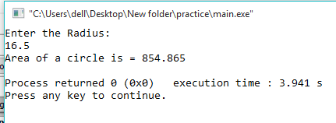

**8.3 Using functions, write a program which takes a character as an input and determines whether it is a vowel or consonant**

**SOURCE CODE**

**#include<iostream>**

**using namespace std;**

**int main()**

**{**

**char udf(void);**

**udf();**

**return 0;**

**}**

**char udf(void)**

**{**

**char a;**

**cout<<"Enter any ALPHABET:"<<endl;**

**cin>>a;**

**if ((a=='a') || (a=='e') || (a=='i') || (a=='o') || (a=='u')||(a=='A') || (a=='E') || (a=='I') || (a=='O') || (a=='U'))**

**{**

**cout<< a << ": is vowel letter!" <<endl;**

**}**

**else**

**{**

**cout<< a << ": is consonant " <<endl;**

**}**

**}**

**OUTPUT**

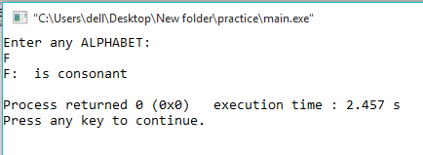

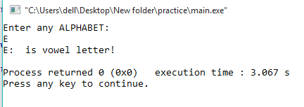

**Lab 9**

**9.1 Write a program that input the marks of five students in an array and find the average.**

**SOURCE CODE**

#include<iostream>

using namespace std;

int main()

{

int array1[5], a=0,average=0;

cout<<"Enter the marks of 5 students"<<endl;

for(int i=0; i<=4; i++)

{

cin>>array1[i];

a = a + array1[i];

}

average = a/5;

cout<<"The average marks of the five students is: "<<average<<endl;

return 0;

}

**OUTPUT**

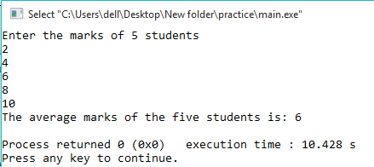

**9.2 Write a program that creates an array of 8 numbers and perform the following: a. Input a number from user and search in array if it is present or not. Also show the position. b. Find the highest number present in array.**

**SOURCE CODE**

#include<iostream>

using namespace std;

int main()

{

int array1[8]={8,16,6,4,12,2,14,10}, a=0,b=0;

cout<<"Enter the number to be checked"<<endl;

cin>>a;

for(int i=0; i<=7; i++)

{

if(a==array1[i])

{

cout<<a<<" is present in the array at position: "<<i<<endl;

break;

}

else if(i==7)

cout<<"Number is not present"<<endl;

if(array1[i]>=b)

{

b=array1[i];

}

}

cout<<"The highest number in array is: "<<b<<endl;

return 0;

}

**OUTPUT**

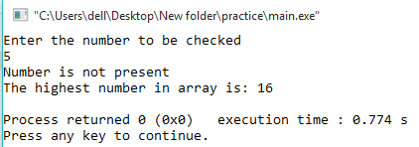

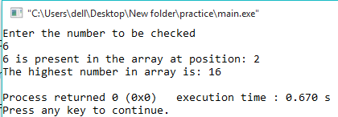

**9.3 Write a program to Convert Uppercase to Lowercase by using string functions.**

**SOURCE CODE**

#include <iostream>

#include <string.h>

using namespace std;

int main()

{

char str1[30];

int i;

cout<<"Enter the string in lowercase: ";

cin>>str1;

strupr(str1);

cout<<"The string in uppercase is: "<<str1<<endl;

return 0;

}

**OUTPUT**

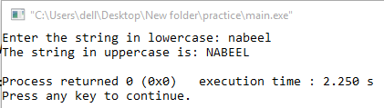

**LAB 10**

**10.1 Write a program that prompts the user to enter the number of elements and the numbers themselves to be placed in an integer array that holds a maximum of 20 elements. The program should then prompt the user for an integer which will be searched for in the array using a binary search. Make sure to include the following steps along the way:**

**i) A sort routine must be called before the binary search. You may use either the selection sort or the bubble sort. However, the sort must be implemented in its own function and not in main. ii) Next include a function called by main to implement the binary search. The ordered array produced by the sort should be passed to the search routine which returns the location in the sorted array of the sought value, or -1 if the value is not in the array**

**SOURCE CODE**

#include<iostream>

using namespace std;

void bubbleSort(int [], int);

int searchBinary( int[], int);

void displayArray(int[], int);

int main ()

{

int userValue;

const int SIZE = 20;

int numArray[SIZE];

cout << "Enter the 20 element numbers to be placed into the integer array." << endl;

for (int count = 0; count < SIZE; count ++)

{

cout << "enter integer #" << count + 1 << " ";

cin >> numArray[count];

}

bubbleSort (numArray, SIZE);

cout << "The array has been sorted." << endl;

displayArray(numArray,SIZE);

cout << "what integer would you like to retrieve?";

cin >> userValue;

cout << "Searching the array..." << endl;

cout << searchBinary(numArray, userValue);

return 1;

}

void bubbleSort (int arrayNumx[], int ELEMS)

{

bool elemswap;

int temp1 = 0;

int endValue = ELEMS - 1;

do

{

elemswap = false;

for (int count = 0; count < endValue; count ++)

{

if (arrayNumx[count] > arrayNumx[count+1])

{

temp1 = arrayNumx[count];

arrayNumx[count] = arrayNumx[count + 1];

arrayNumx[count+1] = temp1;

elemswap = true;

}

}

endValue--;

}

while (elemswap != false);

}

int searchBinary (int intArray[], int quantity)

{

for(int i=0; i<=quantity; i++)

{

if (intArray[i]==quantity)

{

cout<<"Value is present in the array at position: "<<i<<endl;

return 0;

}

}

cout<<"-1"<<endl;

}

void displayArray (int shownum[], int dec)

{

for(int count = 0; count < dec; count++)

cout << shownum[count] << endl;

}

OUTPUT

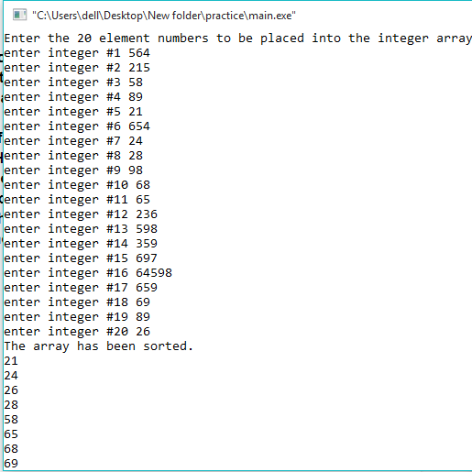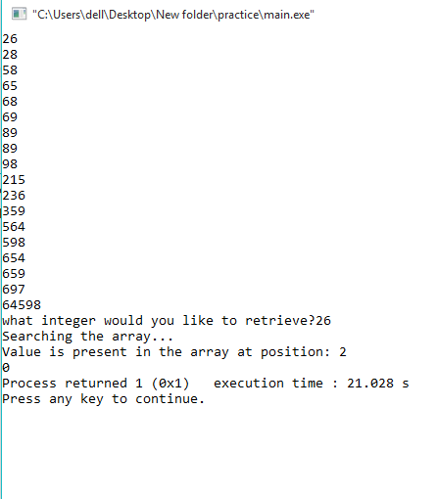

**LAB 11**

**11.1 Write a program which prompts the user to enter his/her name, and marks of 5 different subjects. The program should save the data in a structure and prints the roll no, student name, student subject individual marks and total marks.**

**SOURCE CODE**

#include<iostream>

using namespace std;

struct stdata

{

int rollno;

string name;

int subjectmarks[5];

};

int main ()

{

int total=0;

stdata stdata1;

cout<<"Enter name: "<<endl;

cin>>stdata1.name;

cout<<"Enter roll no: "<<endl;

cin>>stdata1.rollno;

cout<<"Enter marks of 5 subjects: "<<endl;

for(int i=0; i<=4; i++)

{

cin>>stdata1.subjectmarks[i];

total = total + stdata1.subjectmarks[i];

}

cout<<"The name of the student is: "<<stdata1.name<<endl;

cout<<"The roll no of the student is: "<<stdata1.rollno<<endl;

cout<<"The individual marks of the student is: "<<endl;

for(int j=0; j<=4; j++)

{

cout<<stdata1.subjectmarks[j]<<endl;

}

cout<<"The total marks of the student is: "<<total<<endl;

return 0;

}

**OUTPUT**

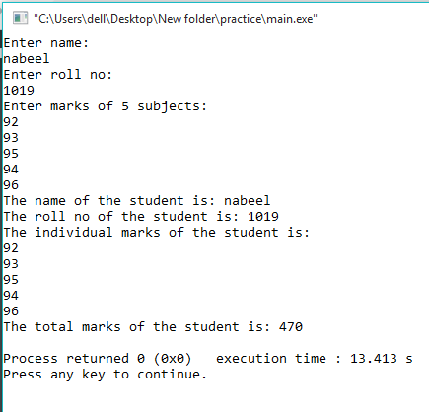

**11.2Using data structures, write a program which takes the input in an amount of seconds and converted into hours, minutes and seconds.**

**SOURCE CODE**

#include <iostream>

using namespace std;

int main()

{

int user = 0;

int hour = 0;

int min = 0;

int sec = 0;

cout << "Enter a time in seconds: ";

cin >> user;

hour = user/3600;

min = user/60;

sec = user;

cout<<"\nThe converted time is is: "<<hour<<" hours, "

<<min<<" minutes, and "<<sec<<" seconds!\n";

return 0;

}

**OUTPUT**

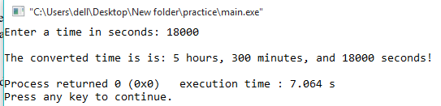

**11.3Write a Program to add, subtract, multiply and divide two complex numbers using structures**

**SOURCE CODE**

#include<iostream>

#include<math.h>

using namespace std;

struct complex

{

float real;

float imgaginary;

}c1,c2;

int main()

{

float a,b;

cout<<"First enter the real and then imaginary part of 1st complex number:";

cin>>c1.real>>c1.imgaginary;

cout<<"First enter the real and then imaginary part of 2nd complex number:";

cin>>c2.real>>c2.imgaginary;

cout<<"Calculating...\n"<<endl;

//For Div

a=(((c1.real)*(c2.real))+((c1.imgaginary)*(c2.imgaginary)))/(pow(c2.real,2)+pow(c2.imgaginary,2));

b=(((c2.real)*(c1.imgaginary))-((c1.real)*(c2.imgaginary)))/(pow(c2.real,2)+pow(c2.imgaginary,2));

cout<<"\nDivision: "<<a<<"+"<<b<<"i";

//For Sub

a=(c1.real)-(c2.real);

b=(c1.imgaginary)-(c2.imgaginary);

cout<<"\nSubtraction: "<<a<<"+"<<b<<"i";

//For Add

a=(c1.real)+(c2.real);

b=(c1.imgaginary)+(c2.imgaginary);

cout<<"\nAddition: "<<a<<"+"<<b<<"i";

//For Multi

a=((c1.real)*(c2.real))-((c1.imgaginary)*(c2.imgaginary));

b=((c1.real)*(c2.imgaginary))+((c2.real)*(c1.imgaginary));

cout<<"\nMultiplication: "<<a<<"+"<<b<<"i";

return 0;

}

**OUTPUT**

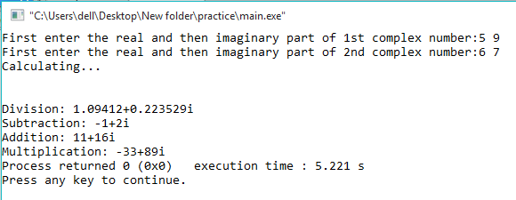

**LAB 12**

**12.1 Write a program in C++ to find the maximum number between two numbers using a pointer**

**SOURCE CODE**

**#include <iostream>**

**using namespace std;**

**int main()**

**{**

**int fno,sno,*ptr1=&fno,*ptr2=&sno;**

**cout<<"Input the first number : ";**

**cin>>fno;**

**cout<<"Input the second number : ";**

**cin>>sno;**

**if(*ptr1>*ptr2)**

**{**

**cout<<"The maximum number is: "<<*ptr1<<endl;**

**}**

**else**

**{**

**cout<<"The maximum number is: "<<*ptr2<<endl;**

**}**

**}**

**OUTPUT**

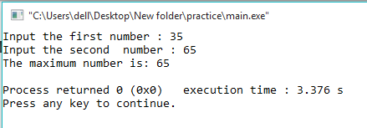

**11.2 Write an any example in C++ of passing Pointers to functions**

**SOURCE CODE**

**#include <iostream>**

**using namespace std;**

**int funtionthatcallsapointer(int *a, int *b, int *c)**

**{**

**\*c = *a + *b;**

**}**

**int main()**

**{**

**int a,b,c=0;**

**cout<<"Enter a first number: "<<endl;**

**cin>>a;**

**cout<<"Enter a second number: "<<endl;**

**cin>>b;**

**funtionthatcallsapointer(&a, &b, &c);**

**cout<<"The sum of the input is: "<<c;**

**}**

**OUTPUT**

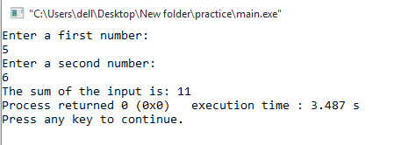

**12.3 Write a program in C++ to show the basic declaration of pointer.**

**SOURCE CODE**

**#include <iostream>**

**using namespace std;**

**int main()**

**{**

**int m=10, n, o;**

**int *z = &m ;**

**cout<<"-------------------------------------------------------\n"<<endl;**

**cout<<" Here is m=10, n and o are two integer variable and *z is an integer"<<endl;**

**cout<<"\n\n z stores the address of m = "<<z<<endl;**

**cout<<"\n *z stores the value of m = "<<*z<<endl;**

**cout<<"\n &m is the address of m = "<<&m<<endl;**

**cout<<"\n &n stores the address of n = "<<&n<<endl;**

**cout<<"\n &o stores the address of o = "<<&o<<endl;**

**cout<<"\n &z stores the address of z = "<<&z<<endl;**

**}**

**OUTPUT**

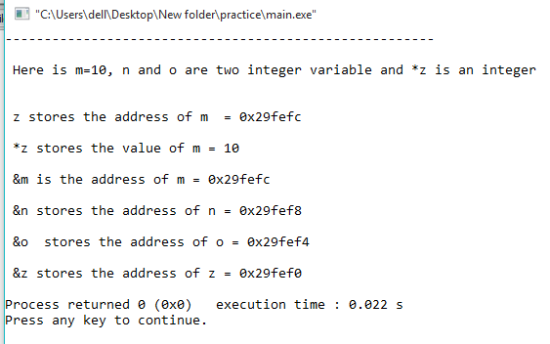

**LAB 13**

**13.1 Write a program that inputs five names and writes them to a text file “name.txt”**

**SOURCE CODE**

**#include <iostream>**

**#include <fstream>**

**using namespace std;**

**int main()**

**{**

**ofstream file ("NewFile.txt");**

**file << "Nabeel Rizwan Quadri" << endl;**

**file << "Hassan Lodhi" << endl;**

**file << "Uzair baig" << endl;**

**file << "Hubab Alvi" << endl;**

**file << "Hafiz Hamza Khan" << endl;**

**file.close();**

**return 0;**

**}**

**OUTPUT**

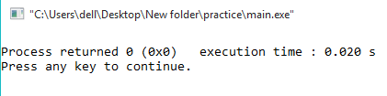

**13.2 Write a program that retrieves all the data from the text file “name.txt”**

**SOURCE CODE**

**#include <iostream>**

**#include <fstream>**

**#include <string>**

**using namespace std;**

**int main ()**

**{**

**string line;**

**ifstream file ("NewFile.txt");**

**if (file.is_open())**

**{**

**while ( file.good() )**

**{**

**getline (file,line);**

**cout<< line <<endl;**

**}**

**file.close();**

**cout<<"file ended \n";**

**}**

**else**

**cout<<"Unable to open file";**

**return 0;**

**}**

**OUTPUT**

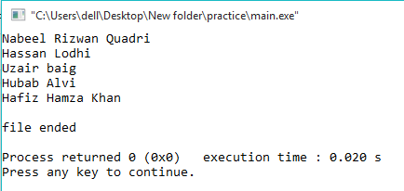

**LAB 14**

**14.1Using the following UML diagram, create the “Student” class and define and declare all necessary data members and member functions. Then use main function to call these member functions**

**SOURCE CODE**

**#include <iostream>**

**using namespace std;**

**class student**

**{**

**public:**

**string name;**

**char grade;**

**public:**

**void getname()**

**{**

**cout << "Enter your name: ";**

**cin >> name;**

**cout << "\nEnter your grade: ";**

**cin >> grade;**

**}**

**void printgrade()**

**{**

**cout << "\nThe grade of " << name << " is " << grade << endl;**

**}**

**};**

**int main()**

**{**

**student s; //creating objects**

**s.getname();**

**s.printgrade();**

**return 0;**

**}**

**OUTPUT**

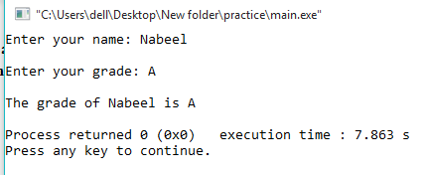

**14.2 Write a program to perform an inheritance any of your choice.**

**SOURCE CODE**

**#include <bits/stdc++.h>**

**using namespace std;**

**//Base class**

**class Parent**

**{**

**public:**

**int id_p;**

**};**

**// Sub class inheriting from Base Class(Parent)**

**class Child : public Parent**

**{**

**public:**

**int id_c;**

**};**

**//main function**

**int main()**

**{**

**Child obj1;**

**// An object of class child has all data members**

**// and member functions of class parent**

**obj1.id_c = 66;**

**obj1.id_p = 77;**

**cout << "Child id is " << obj1.id_c << endl;**

**cout << "Parent id is " << obj1.id_p << endl;**

**return 0;**

**}**

**OUTPUT**

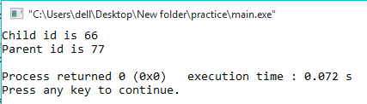

**14.3 Write C++ program to create class to read time in HH:MM:SS format and display into seconds**

**SOURCE CODE**

**#include <iostream>**

**#include <iomanip>**

**using namespace std;**

**class Time**

**{**

**private:**

**int seconds;**

**int hh,mm,ss;**

**public:**

**void getTime();**

**void convertIntoSeconds();**

**void displayTime();**

**};**

**void Time::getTime()**

**{**

**cout << "Enter time:" << endl;**

**cout << "Hours? "; cin >> hh;**

**cout << "Minutes? "; cin >> mm;**

**cout << "Seconds? "; cin >> ss;**

**}**

**void Time::convertIntoSeconds()**

**{**

**seconds = hh*3600 + mm*60 + ss;**

**}**

**void Time::displayTime()**

**{**

**cout << "The time is = " << setw(2) << setfill('0') << hh << ":"**

**<< setw(2) << setfill('0') << mm << ":"**

**<< setw(2) << setfill('0') << ss << endl;**

**cout << "Time in total seconds: " << seconds;**

**}**

**int main()**

**{**

**Time T; //creating objects**

**T.getTime();**

**T.convertIntoSeconds();**

**T.displayTime();**

**return 0;**

**}**

**OUTPUT**

